3.1 Functions of Two or More Variables Worksheet

- For each of the following functions state the domain & range in set notation and create a picture of the domain in the xy-plane.
- .

- For each function, label its graph from among the options below by writing the corresponding letter in the box next to the graph.
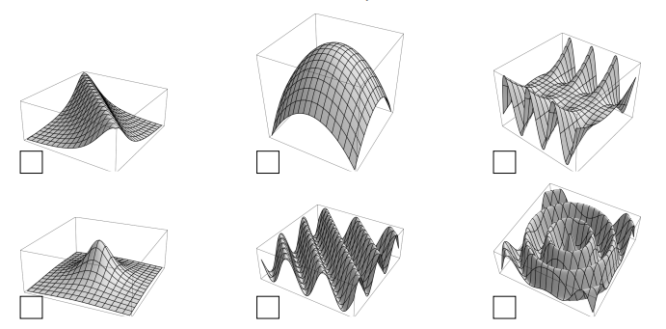
(A) (B)

- For each graph below, find the corresponding function from the options at the right and write the corresponding letter in the box next to the graph.
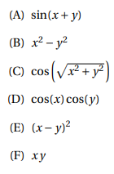
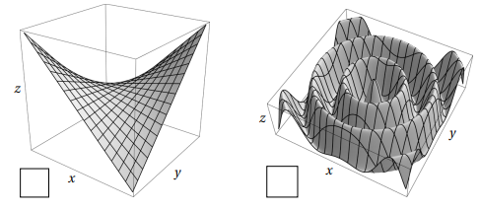

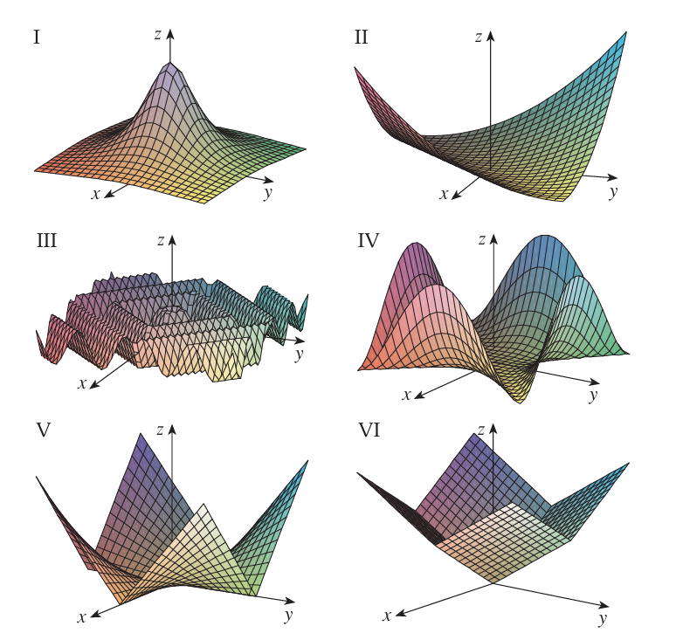
- Match the function with its graph.

- Match the following functions with their graphs and level set diagrams.
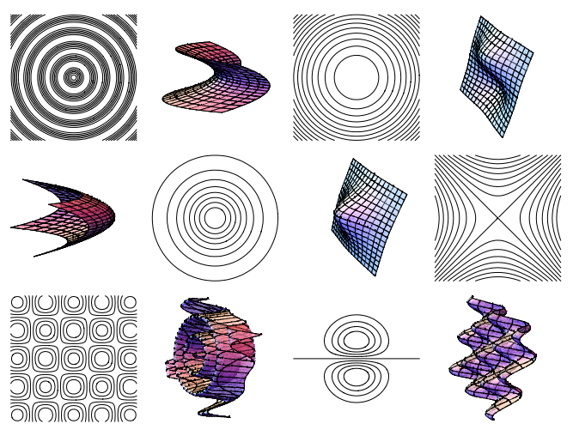

- Match the function with its graph and with its contour map.
